**The Wheels on the Truck**

(adapted from *The Wheels on the Bus*)

C:\Users\marsha\AppData\Local\Microsoft\Windows\Temporary Internet Files\Content.IE5\QAINF9L7\MC900310940[1].wmf

The wheels on the truck go round and round,

round and round,

round and round.

The wheels on the truck go round and round

Bringing goods to market.

C:\Users\marsha\AppData\Local\Microsoft\Windows\Temporary Internet Files\Content.IE5\MBNFYF0V\MC900305637[1].wmfThe truck is filled with bats and balls,

Books and shoes,

Clothes and toys.

The market has many goods for sale

All for consumers to purchase.

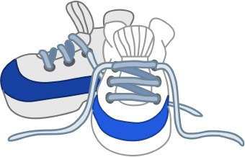

C:\Users\marsha\AppData\Local\Microsoft\Windows\Temporary Internet Files\Content.IE5\F6SHM858\MC900435546[1].wmf

