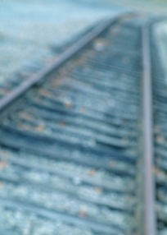 Crew Productivity Data

Name of work crew:

Name of crew member: __________________________________________

Name of crew member: __________________________________________

Name of crew member: __________________________________________

Name of crew member: __________________________________________

Name of crew member: __________________________________________

|  |  |  |
| --- | --- | --- |
|  | Round 1 | Round 2 |
| Number of workers in crew |  |  |
| Number of completed track sections |  |  |
| Productivity : output per worker  (line 2) ÷ (line 1) |  |  |

C:\Users\geanie\AppData\Local\Microsoft\Windows\Temporary Internet Files\Content.IE5\C2FKKLNP\MC900320954[1].wmf

*C:\Users\geanie\AppData\Local\Microsoft\Windows\Temporary Internet Files\Content.IE5\1U4Z5QRU\MC900358031[1].wmfClass Work Crew Productivity Data*

***Crew name Round 1 Round 2***

|  |  |  |
| --- | --- | --- |
|  |  |  |
|  |  |  |
|  |  |  |
|  |  |  |
|  |  |  |
|  |  |  |
|  |  |  |
|  |  |  |
|  |  |  |

Railroad Track Cross Ties

(color brown)

|  |
| --- |
|  |
|  |
|  |
|  |
|  |
|  |
|  |
|  |
|  |
|  |
|  |
|  |

Railroad Track Rails

(color black)

|  |  |  |  |  |  |  |  |
| --- | --- | --- | --- | --- | --- | --- | --- |
|  |  |  |  |  |  |  |  |

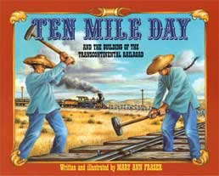

Adapted from a lesson by Todd Zartman, Federal Reserve Bank of Philadelphia

Based on the book: Ten Mile Day by Mary Ann Fraser

Complete lesson can be found at

http://stlouisfed.org/education_resources/assets/lesson_plans/TenMileDay.pdf