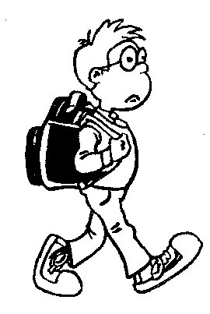
If the Shoe Fits…MOVE!!!

Anchoring Activity: This activity can be used as an introduction for new students/workshop participants or as a review for an “I Learned Today” Statement.

Teacher Prep: Count the number of students or workshop participants. Provide one color of either copy or construction paper for each participant. Place the paper spaced out on the classroom floor.

Instructions:
- Ask each participant to stand on one of the sheets of paper.
- Explain: If the statement read applies to you, you must quickly move to a new sheet of paper at least 2 spots from where you started. If you find yourself without a sheet of paper, please come to the center of the space.
- PREPARE to remove one sheet of paper IMMEDIATELY after the first statement is read.
- Read the first statement and remove one sheet of paper.
- The person left in the center will share something they have learned or answer a question. (this depends on your purpose for doing the activity)
  - Examples:
    - “Most important thing I’ve learned today”
    - Natural Resources- Name a natural resource found in Arkansas.
- Read the next statement. All participants affected will move the person in the center will try to find a sheet of paper as well.
- Repeat the process.
Move if…
- You can name 3 modes of transportation.
- You can name a worker who uses a truck every day to do his/her job.
- You have ridden on a plane in the past 6 months.
- You can name 2 Arkansas trucking firms.
- You have been a consumer in the past 24 hours.
- You can identify a service you consumed that is related to transportation.
- You can name a worker, other than a pilot, that uses a plane to do his/her job.
- You have an economic want in regards to transportation.
Common Core Standards:
- CC.SL.K.1 Comprehension and Collaboration: Participate in collaborative conversations with diverse partners about kindergarten topics and texts with peers and adults in small and larger groups.
- CC.L.Vocabulary Acquisition and Use: With guidance and support from adults, demonstrate understanding of figurative language, word relationships and nuances in word meanings.
- CC.SL.2.1 Comprehension and Collaboration: Participate in collaborative conversations with diverse partners about grade 2 topics and texts with peers and adults in small and larger groups.
- CC.SL.3.1 Comprehension and Collaboration: Engage effectively in a range of collaborative discussions with diverse partners on grade 3 topics and texts, building on others’ ideas and expression their own clearly.
- CC.L.4.5 Vocabulary Acquisition and Use: Demonstrate understanding of figurative language, word relationships, and nuances in word meanings.

