Mapping Arkansas
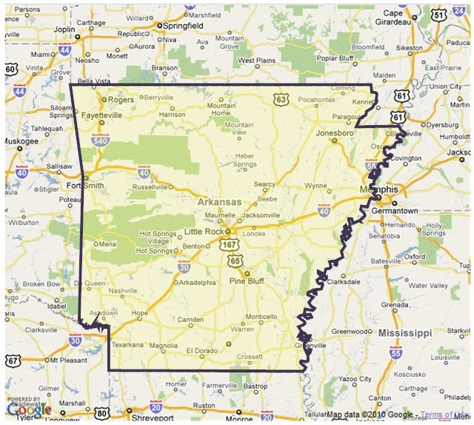
Materials Needed:
- Ball of yarn
- Major cities of Arkansas Cards( found on CD)
- Bordering states cards (found on CD)
- Compass direction cards (found on CD)
- Open space for activity
- Arkansas map for reference
- Box of Arkansas products
(Refer to Arkansas Products listing for ideas.)

Arkansas Social Studies Frameworks:
- G.1.1.11 Name and label the cardinal directions on a map.
- G.1.2.3 Locate the capital of Arkansas .
- G.1.3.2 Name and locate the states that border Arkansas.
- E.8.K.2 Discuss the roles of producers and consumers.
- E.8.1.1 Recognize that people are producers of goods and services.
- E.8.1.2 Recognize that people are consumers of goods and services.
- E.8.2.1 Distinguish between consumers and producers in a local community.
- E.8.K.4 Discuss natural resources.
- E.8.1.4 Identify uses for natural resources.
- E.8.2.3 Discuss the availability of natural resources.
- E.9.3.6 Describe the benefits of voluntary exchange.
- E.9.4.5 Explain why countries trade.
- E.9.2.7 Define specialization and interdependence.
- E.9.3.7 Recognize the connection between specialization and interdependence.
- E.9.4.6 Explain the benefits of specialization and interdependence.

Procedure:
1. Ask for volunteers or select several students to come to the open space on the floor.
2. With the ball of yarn, ask the selected students to create the outline shape of the state of Arkansas. (If necessary, refer to the Arkansas map.)
3. Once the outline of the shape has been created, ask students to place the major cities, bordering states, and the compass directions on the map in the appropriate locations.
4. Ask the remaining students to select a product out of the Arkansas Product Box and stand around the outline of Arkansas.
5. One at a time, ask each student to identify their product and where that product is found in the state. (Many of the products identify the Arkansas city. The teacher may need to offer some assistance by referring to the product listing sheets.)
6. Each student will place the product in the correct area of the state.
7. Continue this process until all the products have been placed.
8. Ask students if they feel any of the Arkansas products on the map might be sold to consumers in other states and other countries.(Yes.)
9. Ask students if they have things in their homes that they don’t see on the state product map. (Yes.)
10. How do we get products to markets around the United States and the world? How do goods from other states and countries make it to our markets? (Transportation: trucks, boats, planes, railroads, etc.)
11. Note: For older students, this is a perfect place to begin a study on the major trucking companies in Arkansas. Students can also research the railroad industry and industries that rely on waterways to transport goods.

