Just Fine the Way They Are!
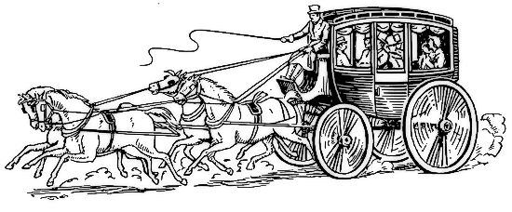
Cast of Characters:
Narrator 1
Narrator 2
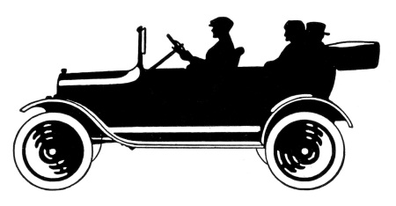
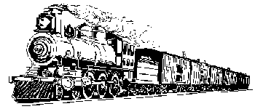
Narrator 3
Narrator 4
John Strack
Mr. Stockton
Farmer

Narrator 1: The year was 1805. Two high minded senators – one from Ohio and one from Connecticut – were telling U.S. Congress that the United States needed a National Road so the folks who lived in the East could get to the Ohio River. These two fancy-talking Senators felt a National Road would cement the Union and “make the crooked ways straight, and the rough ways smooth.” But John Strack wasn’t so sure…
ALL: Why not?
JOHN STRACK: I like the dirt roads just fine. Wagon drivers spend the night at my tavern when their wagons get stuck in the mud coming up the hill. Then they spend the next day digging out and bed down another night. A good road is bad for business. I want none of it! Things are fine just the way they are.
ALL: Just fine the way they are!
NARRATOR 1: Congress went and built the National Road anyway even though John Strack thought things were fine just the way they were. The National Road kept going and going until…
ALL: Until what?
NARRATOR 1: It stopped because of arguments over money and about which way the road should go from there.
ALL: Then what happened?
NARRATOR 1: Well….
ALL: Well, what?
NARRATOR 1: Most folks thought the National Road was a real fine thing. They thought it was the Main Street of America, where ideas and people and things to sell moved back and forth across the country. So, additional money was allocated for the National Road.
NARRATOR 2: The year was 1830. Even before the National Road was completed, Mr. Lucius Stockton was not happy – not happy at all!
ALL: Not happy, not happy? Why not?
MR. STOCKTON: Well, I am an entrepreneur of the National Road Stage Company. I provide a valuable service to travelers. This Peter Cooper fellow has gone and invented a newfangled thing called a steam locomotive that can be pulled over two steel rails at 15 miles per hour!
ALL: 15 miles per hour! Wow!
MR. STOCKTON: That’s right! But who needs a “rail” road when there’s a National Road? Things are fine just the way they are.
ALL: Just fine the way they are!
NARRATOR 2: Many folks thought Peter Cooper and the passenger train was a real fine thing. In fact, the National Road turned into a dirt path used only by a few farmers to haul their goods to town.
ALL: Then what happened?
NARRATOR 3: The year was 1908. Henry Ford’s first Model T automobile appeared. Now there was a personal mobility machine that could go places a train couldn’t, and…
ALL: And what?
NARRATOR 3: Henry Ford increased productivity with the invention of the assembly line. This made cars affordable to many, and there was a great demand for cars.
ALL: And everyone was happy?
NARRATOR 3: Well…
ALL: Well, what?
NARRATOR 3: Not exactly. Now people wanted more and better roads. Well, some people didn’t….
FARMER: Hogwash! The old roads are good enough for a horse and wagon. Everyone else can take a train! Things are fine just the way they are.
ALL: Just fine the way they are!
NARRATOR 3: People were tired of crowded train stations with routes and schedules that bossed them around and told them where they could go and when they could get there. Cars seemed like a good idea to them.
ALL: Was everyone happy now?
NARRATOR 4: The year was 1912. Congress voted to spend money for a national highway system that would include the National Road. In 1920, roads were connected and numbered so people could follow numbers and go where they wanted. U.S. 40 stretched 3,000 miles across the country…right through Arkansas. Most people thought all of this was real fine.
ALL: Then what happened?
NARRATOR 4: By the 1950s, the military folks needed to be able to move from place to place fast if they were going to defend the nation…providing a public service. Congress decided to build a whole new system of roads, right next to the old roads that would have entrances and exits and not stop signs. Military vehicles, cars and trucks taking goods to market could get where they wanted to go even faster. Some folks kept driving on the National Road, but more chose the road right next to it-the interstate-because the towns and stop signals along the National Road slowed them down too much. By the end of the 1900s, most everyone had a car, and some had two or three. And all over the country, there were roads like spaghetti that could get a person just about anywhere. So this story should be ending with a “happily ever after.”
ALL: Well, does it?
NARRATOR 4: Not exactly. Now there are a bunch of folks saying all those cars and all those roads might not be such a good thing…saying there might be an end to how much oil can be pulled out of the earth to make into gasoline…saying that cars are dirtying up the breathing air down here where we live and causing trouble we can only guess at way high up in the atmosphere…So, now some heavy thinkers are coming up with crazy ideas like cars running on electricity and fuel cells and even corn. Next thing they’ll be saying is that we don’t even need cars or roads because they’ve come up with something better.
ALL: So, are things fine just the way they are?
NARRATOR 4: Are they? What do you think?

Source: Just Fine the Way They Are by Connie Nordhielm Wooldridge, Calkins Creek, Honesdale, Pennsyvlania, 2011.

